School Safety Alert System (August 2016)

Developed to align with the safety alert system of the Safe Schools Program.

Policy
Sikh Academy has adopted the School Safety Alert System of the Safe Schools Program to allow for easy transition from Sikh Academy to the public school system and vice versa. The policy is aimed at protecting students, staff, parents, and volunteers during a real or perceived threat to the school.
School Administration is authorized to activate a safety alert, or enact safety alert drills, to ensure student and staff familiarity with the system. Alerts will be enacted over the school’s public announcement system, which is heard both within and outside of the school. There are 3 levels of alert, which come with particular protocols.
Alert Levels:

- Lockdown
- Lockout
- All Clear

LOCKDOWN

A LOCKDOWN will be called during any perceived life-threatening emergency either within the school or within the proximity of the school.
LOCKDOWN is used for situations where there is a dangerous intruder on the school grounds or in the building, or the threat is in the building.

Procedures for the Principal:

The principal will enact a LOCKDOWN if necessary, and the office will proceed with the following steps:

Issue alert by PA: “Attention, this is a LOCKDOWN. This is a LOCKDOWN! Secure the area. All staff and students report to the nearest classroom and remain there until further notice.”
- The school will proceed to secure any areas where the PA address may not have been heard (ie. outside field, restrooms, parking lot, etc.) and bring these individuals into the secured area.
- Office will contact 911 and notify them that we have a LOCKDOWN in progress.
- Office will meet with the Police and follow steps provided by emergency response.
- Principal can evacuate specific rooms, if appropriate and safe to do so.
- A PA message of “All Clear. The past condition is clear.” will alert staff and students that the regular schedule can be resumed.
- The School Safety Alert Team will meet to develop and distribute written notification to students, staff, and parents to explain the reasons for the LOCKDOWN.

Procedures for Individual Classrooms/Teachers

It is expected that individual classrooms have plans for a LOCKDOWN, and these are reviewed with the school Principal and students. These plans should also be readily available for Teachers Teaching on Call for that classroom.

Inside the School Building during a LOCKDOWN:

  - Gather students and staff into closest secured room.
  - Check hallways for anyone, and direct them to the closest secured room (this may not
be the child’s classroom).
  - Lock and close all doors.
  - Close all blinds and windows.
  - Turn off all lights.
  - No one is admitted into the secured room, except the RCMP or school principal.
  - No talking or no phone calls out, except by an adult. Turn off all cell phones and ringers.
  - Adult/Teacher should keep personal cell phone on, but on silent, and answer if called.
  - Take attendance of all people in the secured room on the Accountability form.
  - RCMP will identify self.
  - Follow directions of the RCMP.

“All clear given”.
  - Exit secure room.
  - Bring students to off-site secure area (as per 4.7 and 4.8 School Emergency Evacuation Protocol for Newton and Fleetwood).
  - Take attendance again off all people at the off-site secure area on the Accountability Form.
  - Direct students to return to school, classes, or parents as advised.

Outside the School Building during a LOCKDOWN:

  - Do not enter building.
  - Go directly to the designated off-site-secure area (as per 4.7 and 4.8 School Emergency Evacuation Protocol for Newton and Fleetwood).
  - Take attendance of all persons.

“All clear given.”
  - Wait for others to assemble at off-site secure area.

LOCKOUT

A LOCKOUT (also known as a HOLD AND SECURE) will be called in response to a danger that has been identified outside of the school, or in the surrounding school community.
A LOCKOUT is used for situations where there is a concern about a dangerous individual identified in the immediate vicinity who might enter the school grounds or building.

Procedures for the Principal:

The principal will enact a LOCKOUT if necessary, and the office will proceed with the following steps:

Issue alert by PA: “Attention, this is a LOCKOUT. This is a LOCKOUT! All staff and students report to the nearest classroom or secured area, and remain there until further notice.”
- The school will proceed to secure the building and lock all doors.
- No one is to come in or exit the building after it has been secured.
- Office will contact 911 and notify them we have a LOCKOUT in progress.
- Office will meet with the Police and follow steps provided my emergency response.
- A PA message of “All Clear. The past condition is clear.” will alert staff and students that the regular schedule can be resumed.
The School Safety Alert Team will meet to develop and distribute written notification to students, staff, and parents to explain the reasons for the LOCKOUT.

Inside and Outside the School Building during a LOCKOUT:

  - Gather all students and staff into closest secured room.
  - Close all doors.
  - Close all blinds and windows.
  - Principals/Vice-Principals lock outside doors – depending on situation.
  - Take attendance of all people in the secured room on the Accountability form.
  - LOCKOUT in effect until RCMP declare school safe.

“All clear given.”
  - Students and staff return to regular schedule.

SHELTER IN PLACE LOCKOUT:

Should be used for any environmental or weather related situation where it is necessary to keep all occupants within the school to protect them from an external situation (ie. Chemical spills, blackouts, explosions, extreme weather conditions, etc.).

All Clear

An “ALL CLEAR” is announced over the school’s PA system when there is no longer a threat to the safety of students, staff, parents and volunteers. An “ALL CLEAR” signals for the school to return to normal routines.
Inside and Outside the School Building

  - RCMP informs Principal that the school is safe.
  - Office announces “ALL CLEAR”
  - Normal school operations resume

When classes are not in session (ie. Before/after school, recess, lunch, between classes)

  - Direct all students and staff to the nearest secure room.
  - Follow procedures under LOCKDOWN or LOCKOUT as noted above.

Secured Rooms/Unsecured Rooms Green Areas:
Green Areas are designated shelter or safe areas. These are areas which can be locked down and secured.

Red Areas:

Red Areas designates danger areas, which are areas to avoid. These areas cannot be fully secured. Normally, these areas include libraries, cafeterias, gymnasium, and other common areas.

Blue Areas:

Blue Areas are designated for the RCMP to utilize as a command post. These rooms must have a telephone hardline.
The following Floor Plans note the Green/Red/Blue Areas for Sikh Academy.

Green Circles indicate a Green secured area
Red Stars indicate a Red danger area
Blue Rectangle indicates a possible RCMP command post




Floor Plan - Sikh Academy Newton 1st Floor

Restrooms

Room 104
Room 103

Room 102

Cafeteria Gym

Main Lobby

Restrooms

Storage

101
Office
Room 101
Computer Lab

2nd Lobby

Floor Plan - Sikh Academy Newton 2nd Floor

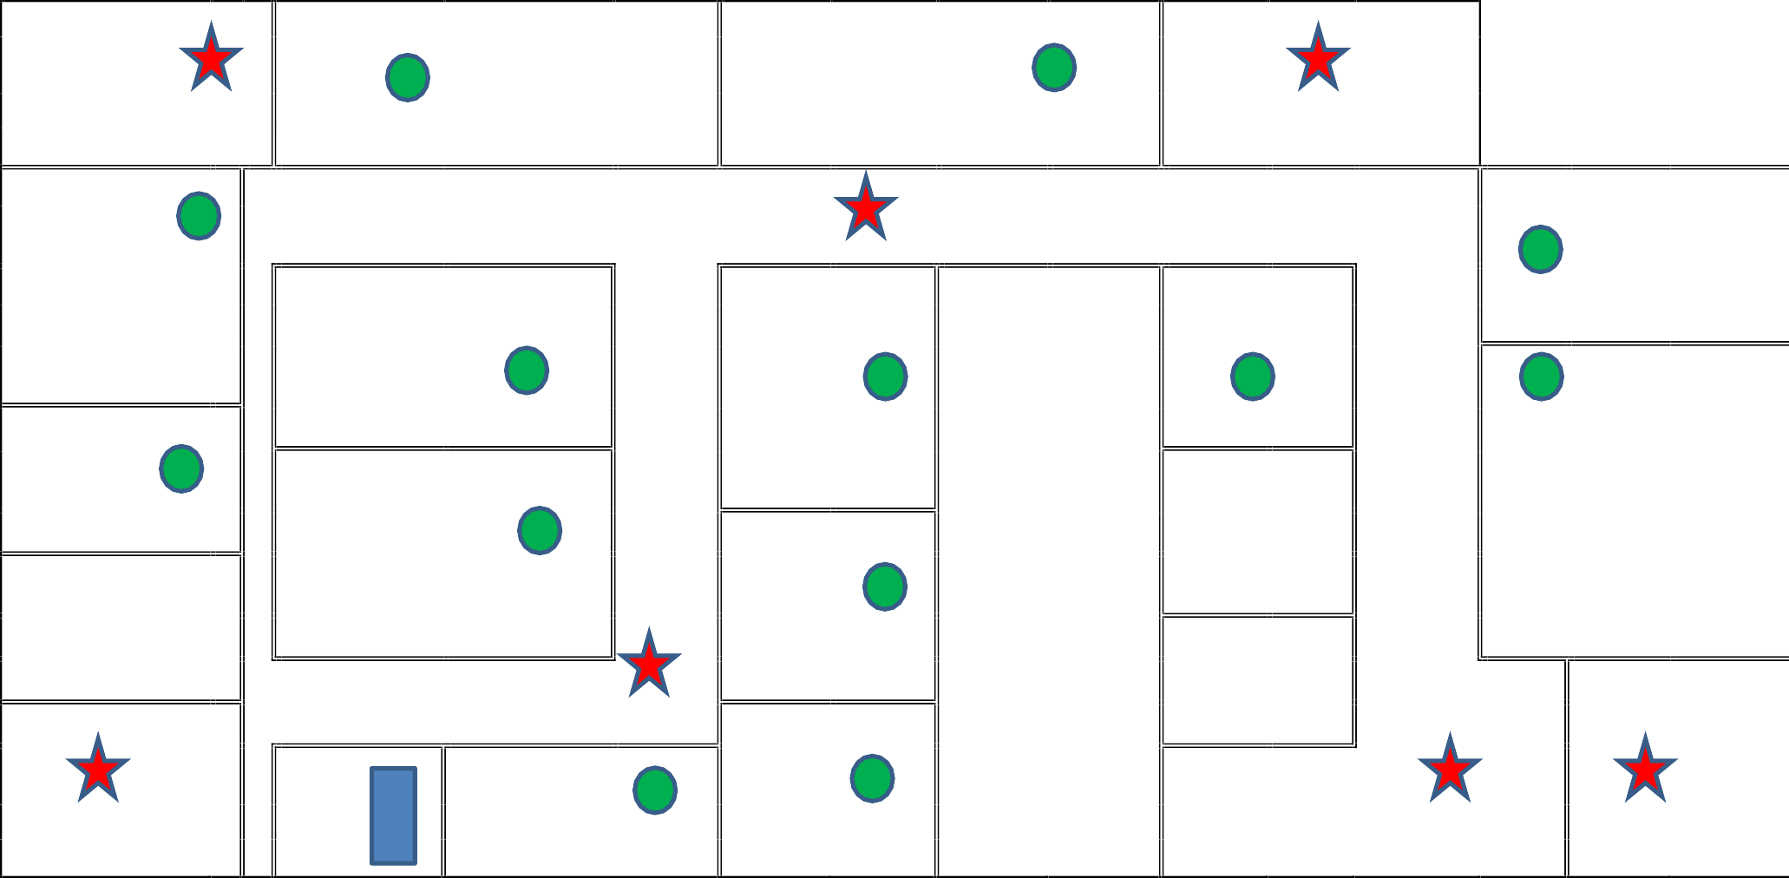
Stairs/Exit

Room 202
Room 201

Stairs/Exit

Room 209
Room 218

Room 211

Room 203

Room 217

Room 208

Restrooms

Room 210

Room 204

Restrooms

Storage
Room 219

Office

Room 206
Room 205

Stairs/Exit






Floor Plan - Sikh Academy Newton
3rd Floor
Stairs/Exit |  | Room 301
Room 302 |  | Room 301 |  |  | Stairs/Exit
Storage
Room 310 | Room 309 | Room 308 | Room 307 |  | Room 303
 |  |  |  |  |  |  | Outside
Vice-Principal |  |  |  |  |  |  | Deck
Room 312 |  |  |  |  | Room 304
Restrooms
 |  |  |  |  | Room  305 | Library
Room 313 | Gurdwara
Religion
 |  |  |  |  |  | Staff | Stairs/Exit
 |  |  |  |  | Room 306 | Room

Sikh Academy Fleetwood
Main Office
Staff Room



Exit
Washrooms
Main office
Gym
Exit
Exit
Exit
Staff Room
Room #2
Room #1
Exit
Room #3
Room #4
Room #6
ab
Computer L
Room #8
Room #7
Room #10
Room #9
Gurdwara
Room #11
Room
#13
Room #14
Exit

School Safety Alert System

School Safety Alert – LOCKDOWN, LOCKOUT, ALL CLEAR, Evacuation – Accountability Form

Sikh Academy: | Teacher: | Grade: Classroom #:
Assembly Area Location: | First Attendance: | Second Attendance:
Assembly Area Location: | 1. | 1.
Date: | 2. | 2.
Notes:  Students/Staff Missing: | 3. | 3.
Notes:  Students/Staff Missing: | 4. | 4.
1. | 5. | 5.
2. | 6. | 6.
3. | 7. | 7.
4. | 8. | 8.
5. | 9. | 9.
6. | 10. | 10.
Excused Absences (Students who were noted as absent in  daily attendance for the day) | 11. | 11.
 | 12. | 12.
 | 13. | 13.
1. | 14. | 14.
2. | 15. | 15.
3. | 16. | 16.
4. | 17. | 17.
5. | 18. | 18.
6. | 19. | 19.
Extra Students with this class: | 20. | 20.
1. | 21. | 21.
2. | 22. | 22.
3. | 23. | 23.
4. | 24. | 24.
5. | 25. | 25.
6. | 26. | 26.
7. | 27. | 27.
8. | 28. | 28.
9. | 29. | 29.
10. | 30. | 30.
STUDENTS/STAFF with Injuries
Name of Student/Staff | Injury | Location of Student/Staff
1.
2.
3.
4.
5.
Date:

